Straight Angle
# Source: AI Source: Provided by: [Data Path: Persons Table -> ID Column: 1, Name_En Column: Motasem Essam] -> From: [ChatGPT] on [7/25/2026]
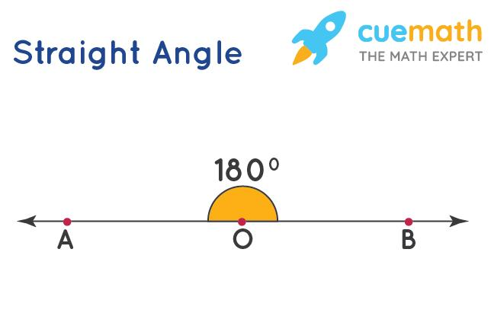
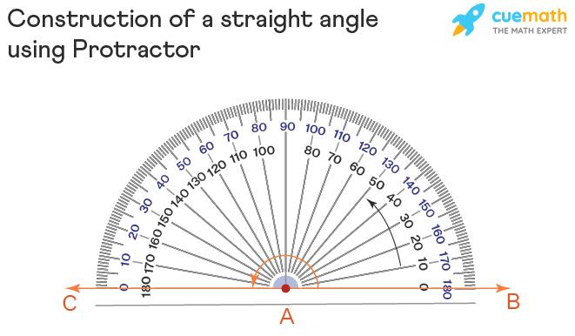
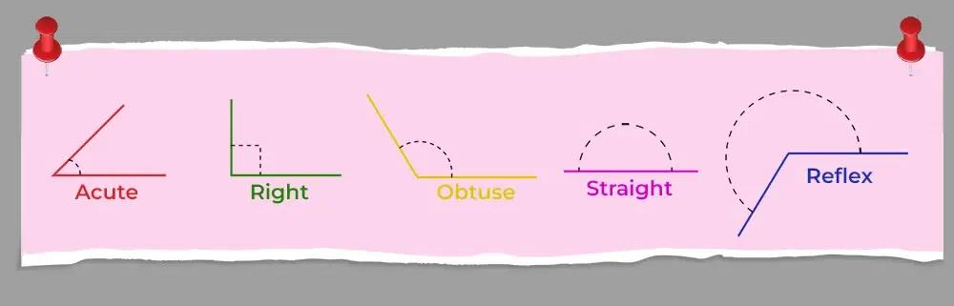
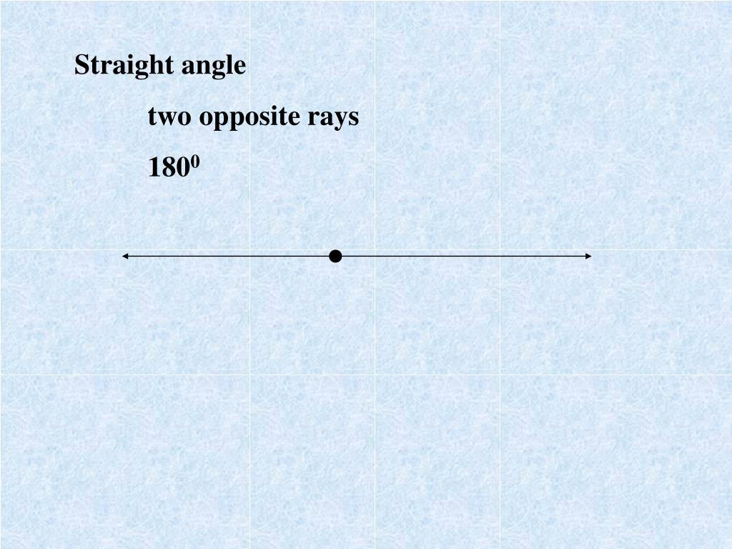
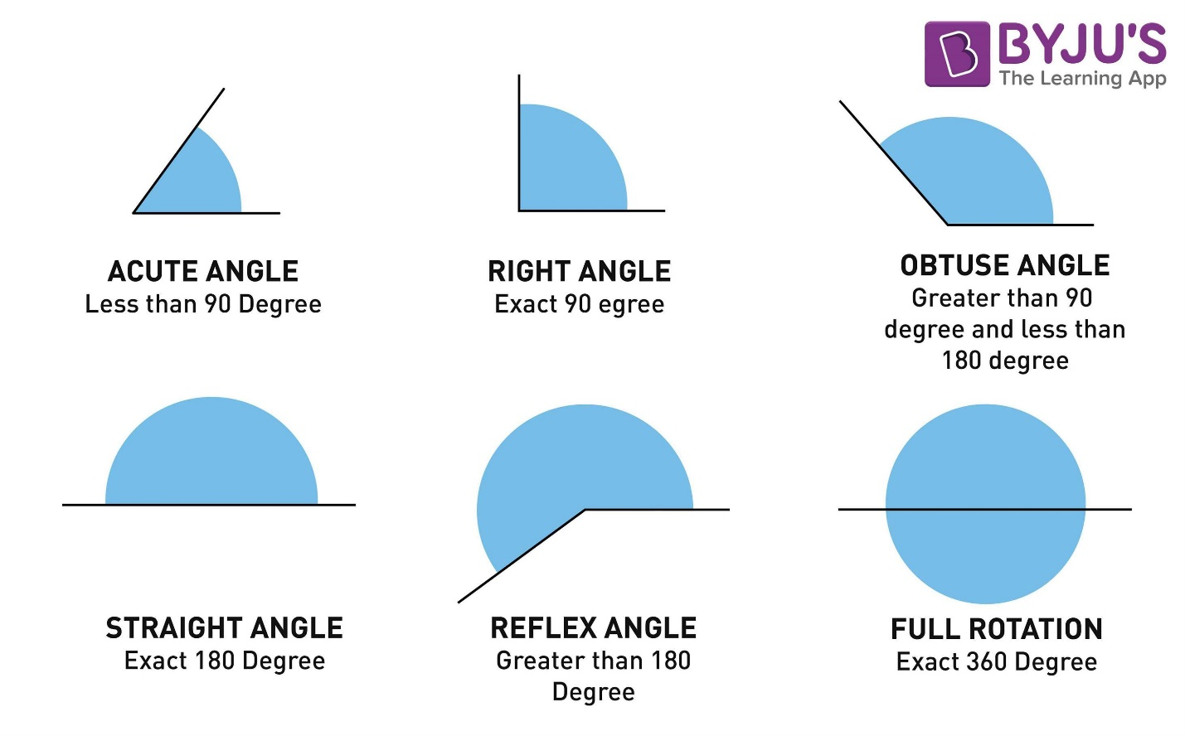

Definition
# Source: AI Source: Provided by: [Data Path: Persons Table -> ID Column: 1, Name_En Column: Motasem Essam] -> From: [ChatGPT] on [7/25/2026]
A Straight Angle is an angle that measures exactly ${180}^{∘}$. It is formed when two opposite rays share a common endpoint and extend in opposite directions along the same straight line.
A straight angle represents half of a full rotation.

Characteristics
# Source: AI Source: Provided by: [Data Path: Persons Table -> ID Column: 1, Name_En Column: Motasem Essam] -> From: [ChatGPT] on [7/25/2026]
A straight angle:
- Measures exactly ${180}^{∘}$.
- Measures exactly $π$ radians.
- Is formed by two opposite rays.
- Forms a straight line.
- Is larger than an obtuse angle and smaller than a complete angle.

Illustration
# Source: AI Source: Provided by: [Data Path: Persons Table -> ID Column: 1, Name_En Column: Motasem Essam] -> From: [ChatGPT] on [7/25/2026]
←────────●────────→
O
The two opposite rays form a straight angle.

Mathematical Representation
# Source: AI Source: Provided by: [Data Path: Persons Table -> ID Column: 1, Name_En Column: Motasem Essam] -> From: [ChatGPT] on [7/25/2026]
A straight angle satisfies:
$$θ={180}^{∘}$$
or
$$θ=π\text{ radians}$$

Formation
# Source: AI Source: Provided by: [Data Path: Persons Table -> ID Column: 1, Name_En Column: Motasem Essam] -> From: [ChatGPT] on [7/25/2026]
Suppose two opposite rays
$$\overset{→}{OA}$$
and
$$\overset{→}{OB}$$
share endpoint
$$O$$
and extend in opposite directions.
Then
$$∠AOB={180}^{∘}$$

Coordinate Geometry
# Source: AI Source: Provided by: [Data Path: Persons Table -> ID Column: 1, Name_En Column: Motasem Essam] -> From: [ChatGPT] on [7/25/2026]
Suppose
$$O\left(0,0\right)$$
One ray passes through
$$A\left(5,0\right)$$
The opposite ray passes through
$$B\left(-5,0\right)$$
The two rays lie on the same line and point in opposite directions.
Therefore,
$$∠AOB={180}^{∘}$$

Straight Angle and Rotation
# Source: AI Source: Provided by: [Data Path: Persons Table -> ID Column: 1, Name_En Column: Motasem Essam] -> From: [ChatGPT] on [7/25/2026]
A straight angle represents half a complete turn.
$${180}^{∘}=\frac{1}{2}×{360}^{∘}$$

Real-World Examples
# Source: AI Source: Provided by: [Data Path: Persons Table -> ID Column: 1, Name_En Column: Motasem Essam] -> From: [ChatGPT] on [7/25/2026]
Straight angles appear in:
- A straight road.
- A ruler.
- A stretched rope.
- A flat tabletop edge.
- The horizon.
- A fully opened book lying flat.

Properties
# Source: AI Source: Provided by: [Data Path: Persons Table -> ID Column: 1, Name_En Column: Motasem Essam] -> From: [ChatGPT] on [7/25/2026]
A straight angle:
- Measures exactly ${180}^{∘}$.
- Is formed by opposite rays.
- Forms a straight line.
- Divides a full angle into two equal halves.
- Is supplementary to another straight angle.

Applications
# Source: AI Source: Provided by: [Data Path: Persons Table -> ID Column: 1, Name_En Column: Motasem Essam] -> From: [ChatGPT] on [7/25/2026]
Straight angles are used in:
- Plane Geometry
- Coordinate Geometry
- Trigonometry
- Engineering
- Architecture
- Construction
- Surveying
- CAD (Computer-Aided Design)
- Robotics
- Computer Graphics

Advantages
# Source: AI Source: Provided by: [Data Path: Persons Table -> ID Column: 1, Name_En Column: Motasem Essam] -> From: [ChatGPT] on [7/25/2026]
Studying straight angles helps to:
- Understand linear geometry.
- Analyze opposite rays.
- Solve angle relationships.
- Construct geometric figures.
- Develop trigonometric concepts.

Limitations
# Source: AI Source: Provided by: [Data Path: Persons Table -> ID Column: 1, Name_En Column: Motasem Essam] -> From: [ChatGPT] on [7/25/2026]
A straight angle:
- Must measure exactly
$${180}^{∘}$$
- Cannot be larger or smaller.

Comparison with Other Types of Angles
# Source: AI Source: Provided by: [Data Path: Persons Table -> ID Column: 1, Name_En Column: Motasem Essam] -> From: [ChatGPT] on [7/25/2026]
Angle Type | Measure
Zero Angle | $$0^{∘}$$
Acute Angle | $$0^{∘}<θ<{90}^{∘}$$
Right Angle | $$θ={90}^{∘}$$
Obtuse Angle | $${90}^{∘}<θ<{180}^{∘}$$
Straight Angle | $$θ={180}^{∘}$$
Reflex Angle | $${180}^{∘}<θ<{360}^{∘}$$
Complete Angle | $$θ={360}^{∘}$$

Key Points
# Source: AI Source: Provided by: [Data Path: Persons Table -> ID Column: 1, Name_En Column: Motasem Essam] -> From: [ChatGPT] on [7/25/2026]
- A Straight Angle measures:
$${180}^{∘}$$
- In radians:
$$π$$
- It is formed by two opposite rays.
- It forms a straight line.
- It represents half of a complete rotation.
- Straight angles are fundamental in geometry, trigonometry, engineering, architecture, surveying, CAD, robotics, and computer graphics.

Conclusion
# Source: AI Source: Provided by: [Data Path: Persons Table -> ID Column: 1, Name_En Column: Motasem Essam] -> From: [ChatGPT] on [7/25/2026]
A Straight Angle is an angle measuring exactly ${180}^{∘}$, formed by two opposite rays extending from a common endpoint in opposite directions. Because it creates a straight line, it serves as a fundamental reference in geometry for understanding linear relationships, supplementary angles, and rotational movement. Straight angles are essential in plane geometry, coordinate geometry, trigonometry, engineering, architecture, construction, surveying, CAD, robotics, and computer graphics, where they are used to represent alignment, straight paths, and half-turn rotations.

